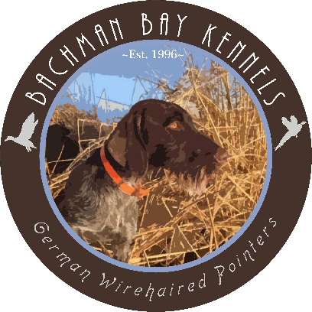

Bachman Bay Outdoors LLC

Dominic & Jill Bachman

PO Box 3022 Princeton, OR 97721

www.bachmanbaykennels.com

**STUD SERVICE CONTRACT**

**VC HRCH CH BACHMAN BAY IMMOBULUS NA1 UT1**

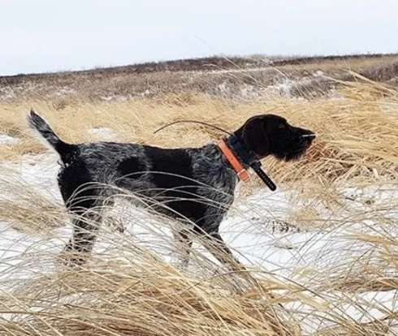Call Name: “Sileaux”

AKC Reg #:SS18280905

NAVHDA#: GW-012151

OFA Hips: Excellent

PennHip: rt. 0.26 lf. 0.27

Elbows: Normal

CERF: Normal

Thyroid: Normal

Cardiac: Normal

DNA Furnishings Test: Ff

Coat: Dense/Harsh

Bite: Normal

CHIC#: 182362

Stud Fee: $2,500 paid in full when bitch delivers at least three live pups. (half fee due if less than three) Fee must be paid before registration will be signed.

**GENERAL CONDITIONS**

Bitch to be bred must have field/working title. Stud caretaker guarantees a live litter of at least three puppies. We suggest all puppies be sold with limited registration. All puppy owners should be strongly encouraged to test their puppies in the NAVHDA Natural Ability test, at minimum.

**Breeding Options**

Currently live cover is the best breeding option. Please coordinate ASAP when you think your Bitch will come into heat. Bitch must be transported to the stud in Mandan, ND or wherever the dog is at time of breeding. A fee of $25 per day will be charged for hosting the bitch if required. Payment for hosting is due at the time of breeding.

**CLEARANCES**

Bachman Bay requires all bitch’s owners to provide copies of OFA Thyroid and OFA/Penn Hip Certification. In addition, we recommend bitches have Elbows, Cardiac, and Eye clearances. In the case of a natural breeding it is required we receive a copy of **a negative Brucellosis prior to bitch arriving at stud**. We would also appreciate a photograph and pedigree of the bitch, and a list of titles for our records.

Stud Dog Owner: Bitch Owner:

Catrina Terry

1101 2nd ave NW 58554

Mandan, ND

Catrina Cell (916)223-2156

Breeder/Co-owner

Dominic Cell(530)708-2141

[Bachmanbaykennels@gmail.com](mailto:Bachmanbaykennels@gmail.com)

Bitch Owner Name:_______________________ Date:________